QPC_simple (19.04.2010 )

OPIS
Uczenie 3 kierunkow QPC startujac z prototypami w centrach klas. Kierunek inicjowany jest losowo. Polozenie prototypow optymalizowane wraz z wagami, rownoczesnie ze wsp. uczenia odpowiednio: lr=0.1 plr=0.1
Test przeprowadzony dla szeregu danych.
Polecenie:
qpctrain_simple(x,y,'learningRate',0.1,'plr',0.1);
Konfiguracja:
procedure = qpcprot
dataname = abalone
vectors = 4177
features = 7
OptMethod = gd
learningRate = 0.100000
prototypes = 28
proto lr = 0.100000
eps = 0.001000
start init. = 1
end init = 3
multistart = yes
maxIterations = 1000
qpc function = @(wx,p)qpcfunction_dt(x,ci,wx,p,func)
function = @(xx)f_gauss(xx,beta)
beta = 0.100000

Projekcje

appendi
Direction 1
QPC=0.5329
LVQ acc.=0.8585
LVQ 1D acc.=0.8585
--
Direction 2
QPC=0.5360
LVQ acc.=0.8491
LVQ 1D acc.=0.8679
--
Direction 3
QPC=0.4984
LVQ acc.=0.8396
LVQ 1D acc.=0.8208
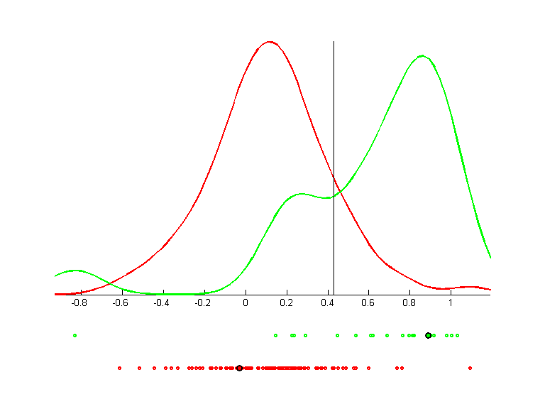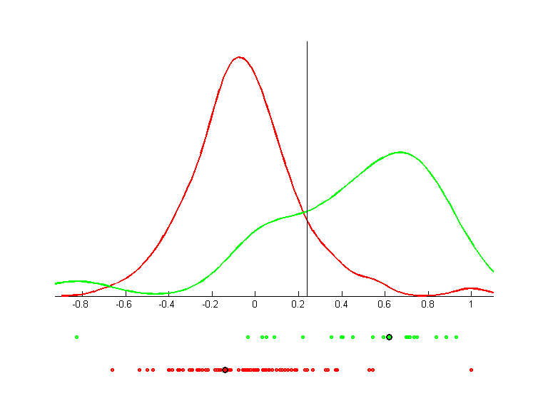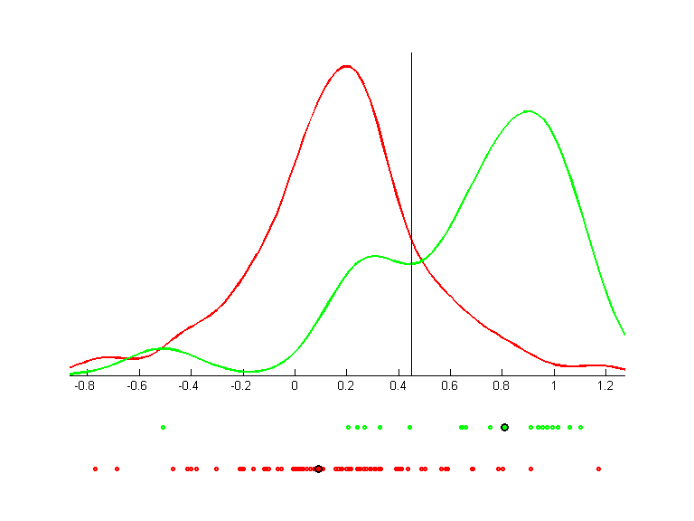 | 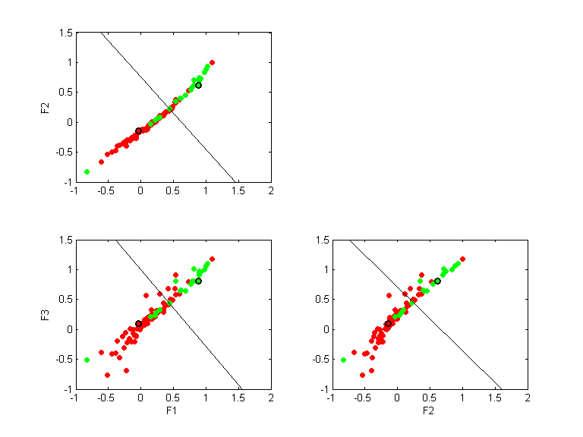

arcene_train
Direction 1
QPC=0.0000
LVQ acc.=0.6300
LVQ 1D acc.=0.6300
--
Direction 2
QPC=-0.0071
LVQ acc.=0.6200
LVQ 1D acc.=0.5900
--
Direction 3
QPC=-0.0000
LVQ acc.=0.6200
LVQ 1D acc.=0.5600
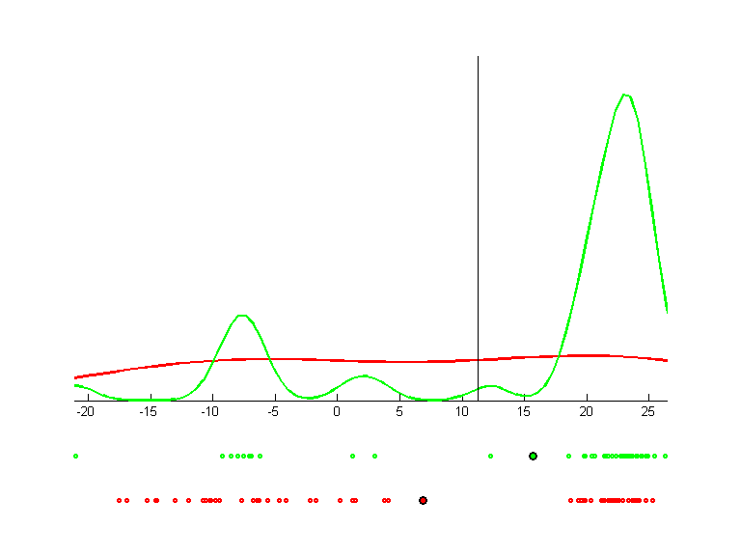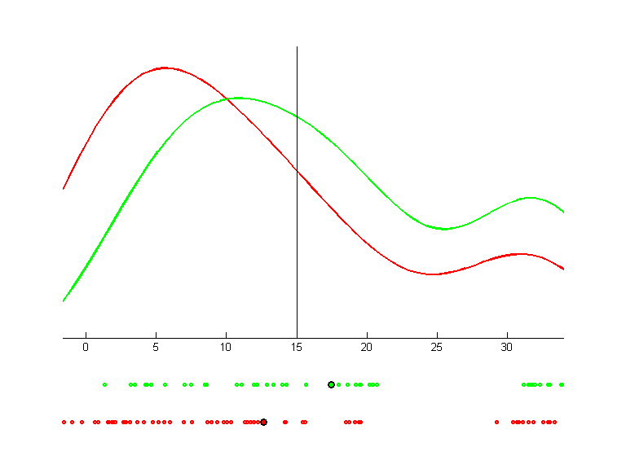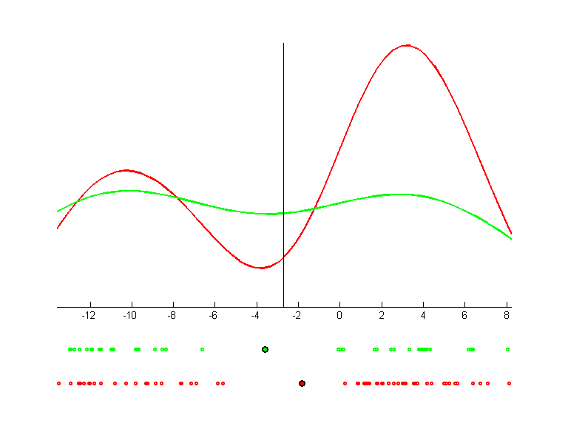 | 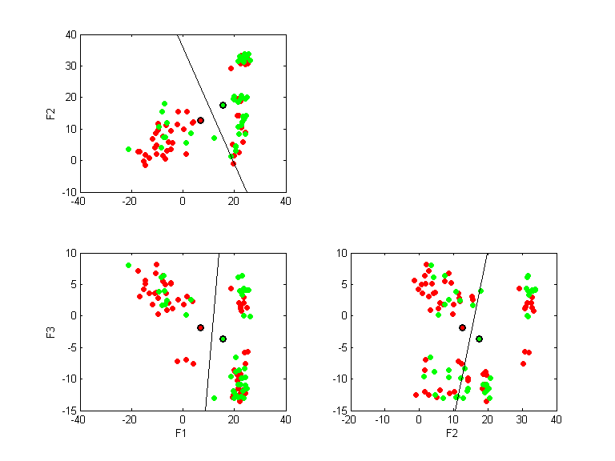

breast-nomis
Direction 1
QPC=0.7104
LVQ acc.=0.9561
LVQ 1D acc.=0.9561
--
Direction 2
QPC=0.8158
LVQ acc.=0.9649
LVQ 1D acc.=0.9619
--
Direction 3
QPC=0.8158
LVQ acc.=0.9663
LVQ 1D acc.=0.9590
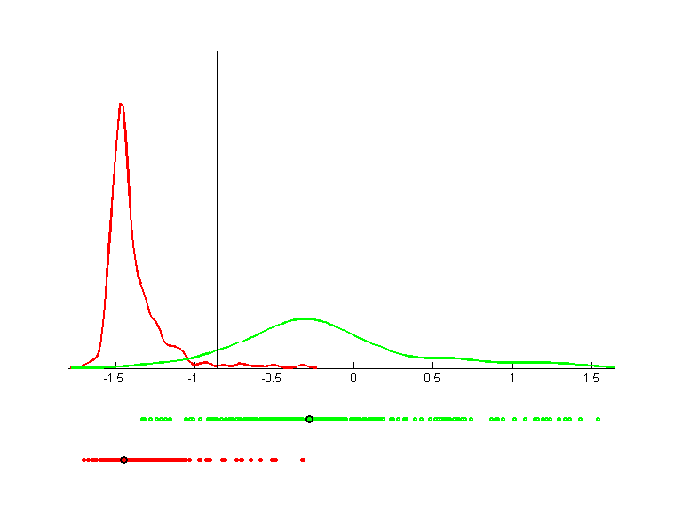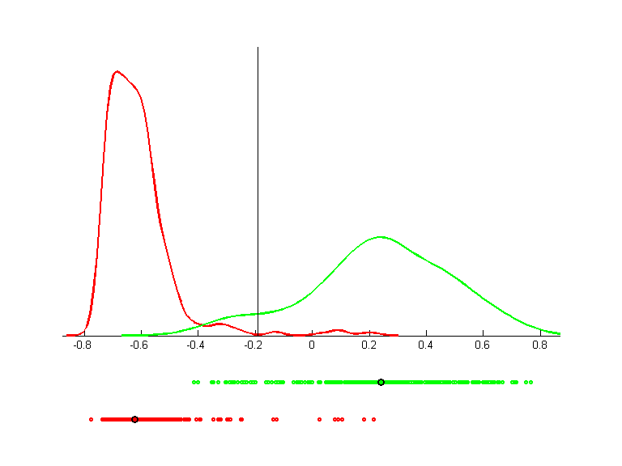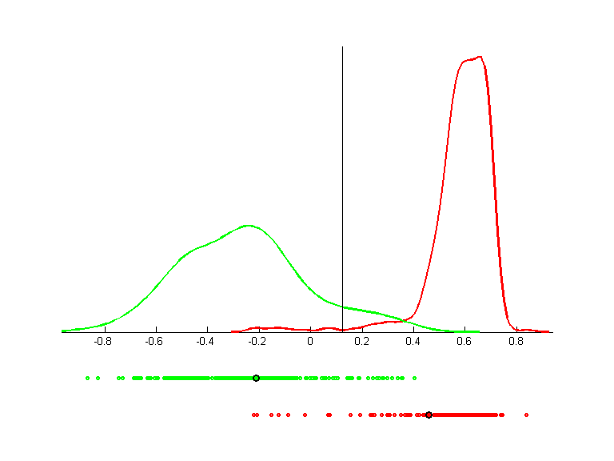 | 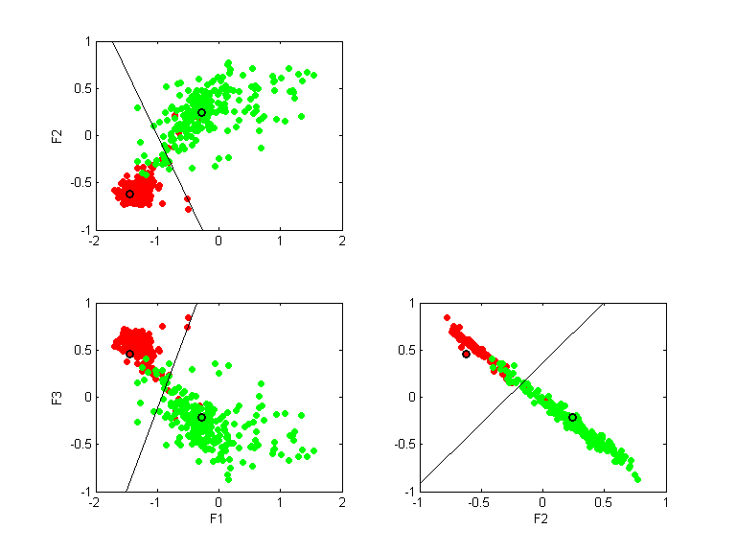

circ4n2
Direction 1
QPC=0.2464
LVQ acc.=0.4563
LVQ 1D acc.=0.4563
--
Direction 2
QPC=0.0338
LVQ acc.=0.3713
LVQ 1D acc.=0.2775
--
Direction 3
QPC=0.1174
LVQ acc.=0.3613
LVQ 1D acc.=0.2975
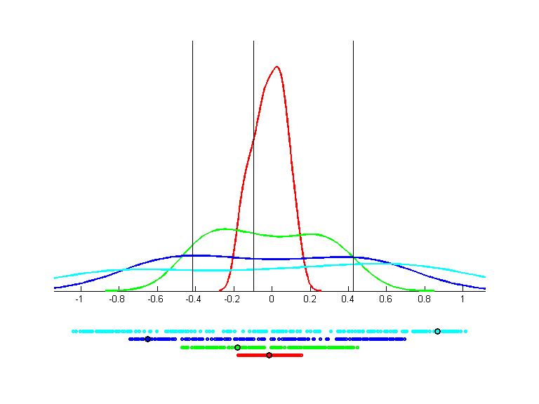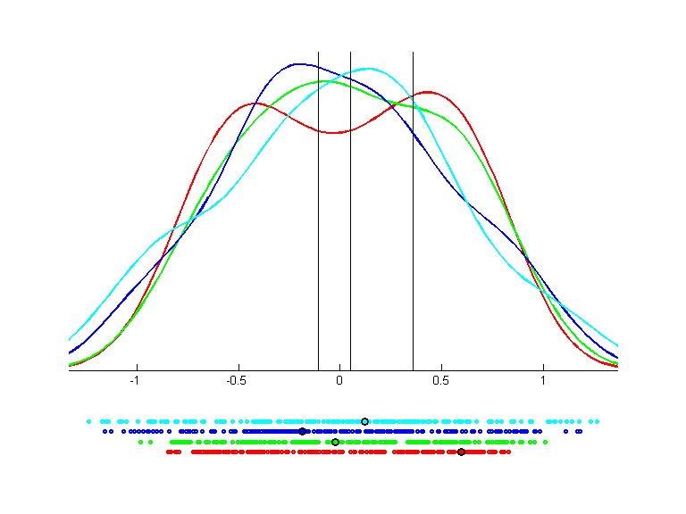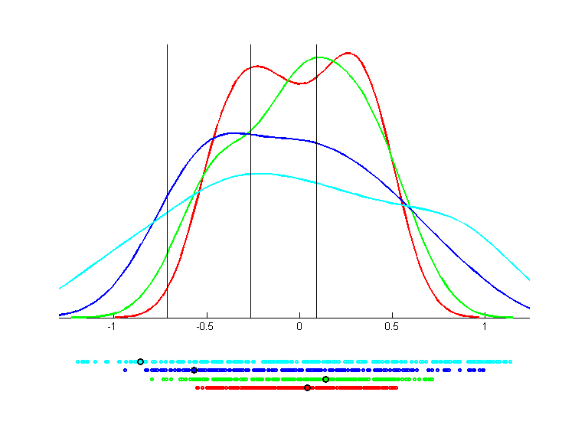 | 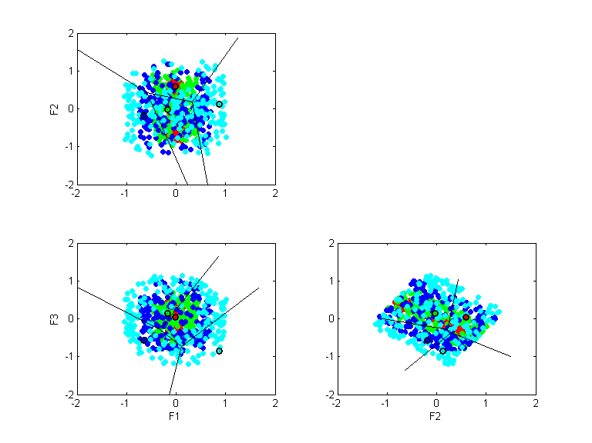

glass
Direction 1
QPC=0.4787
LVQ acc.=0.4346
LVQ 1D acc.=0.4346
--
Direction 2
QPC=0.4251
LVQ acc.=0.4486
LVQ 1D acc.=0.5000
--
Direction 3
QPC=0.3193
LVQ acc.=0.4252
LVQ 1D acc.=0.3411
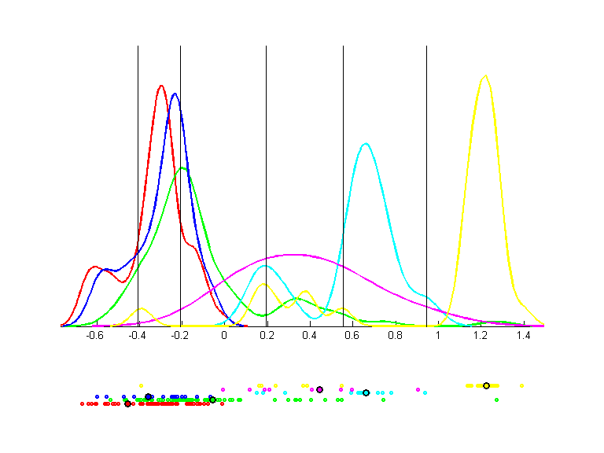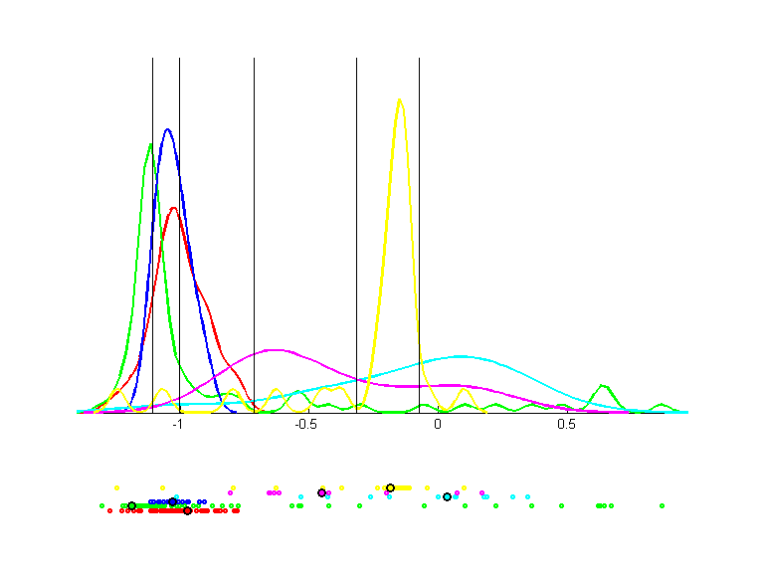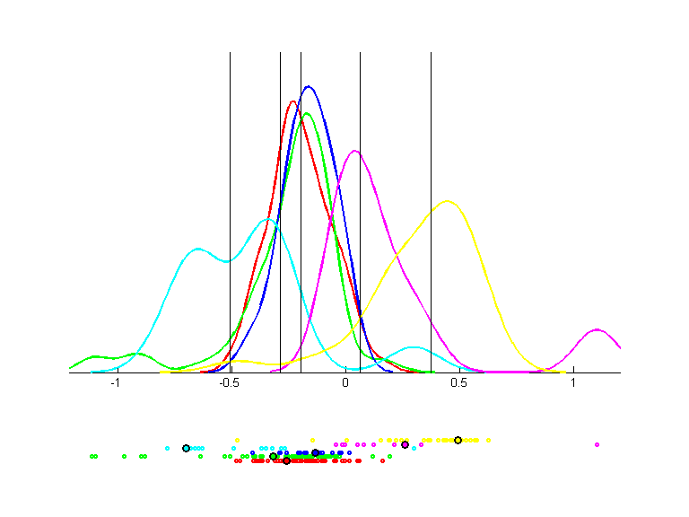 | 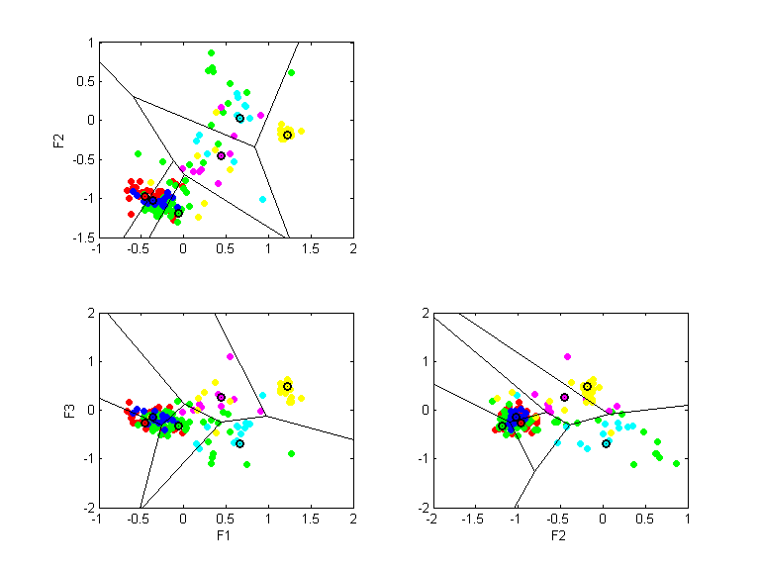

heart-nomis
Direction 1
QPC=0.4932
LVQ acc.=0.8350
LVQ 1D acc.=0.8350
--
Direction 2
QPC=0.5734
LVQ acc.=0.8451
LVQ 1D acc.=0.8418
--
Direction 3
QPC=0.5729
LVQ acc.=0.8519
LVQ 1D acc.=0.8316
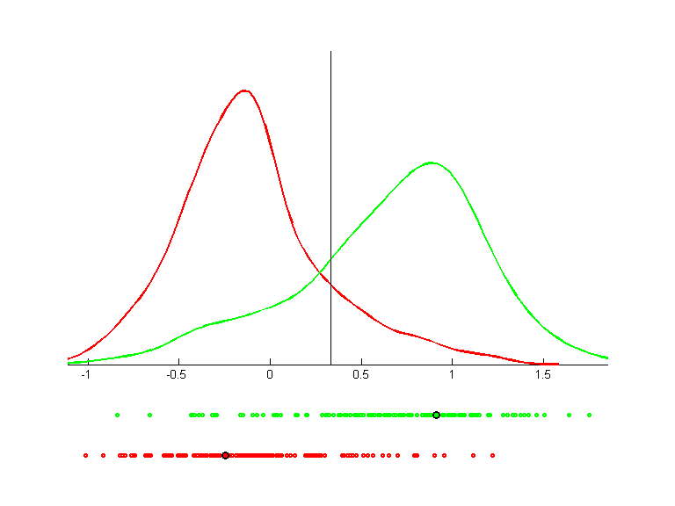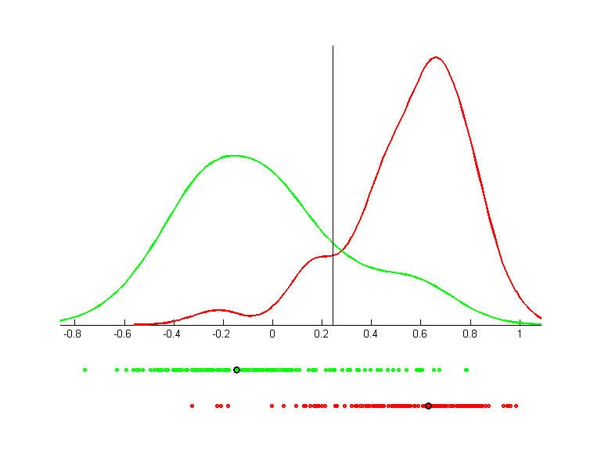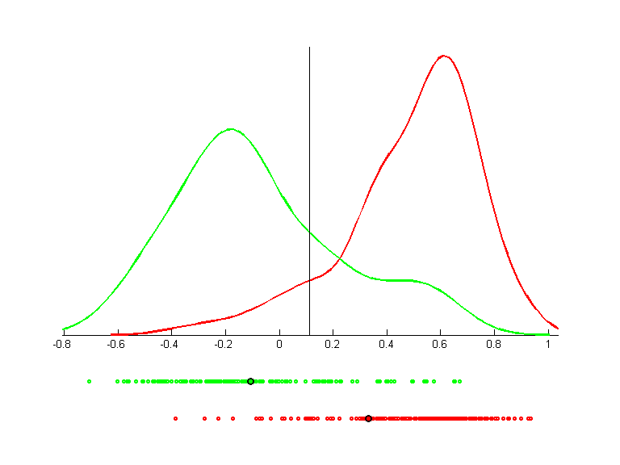 | 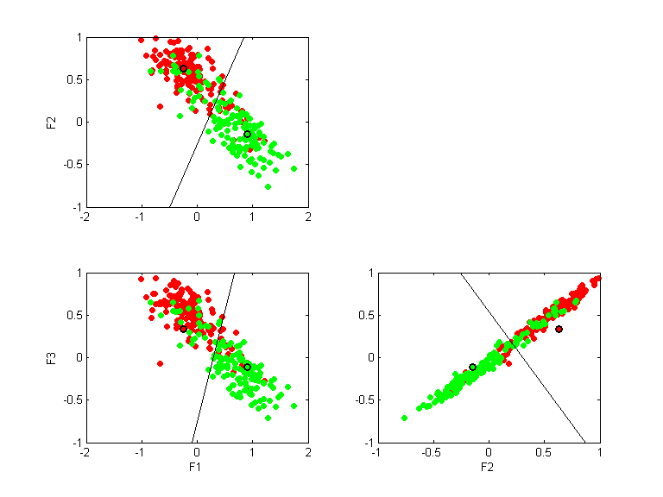

ionosphere
Direction 1
QPC=0.6068
LVQ acc.=0.8450
LVQ 1D acc.=0.8450
--
Direction 2
QPC=0.5647
LVQ acc.=0.8000
LVQ 1D acc.=0.8200
--
Direction 3
QPC=0.6144
LVQ acc.=0.8100
LVQ 1D acc.=0.8700
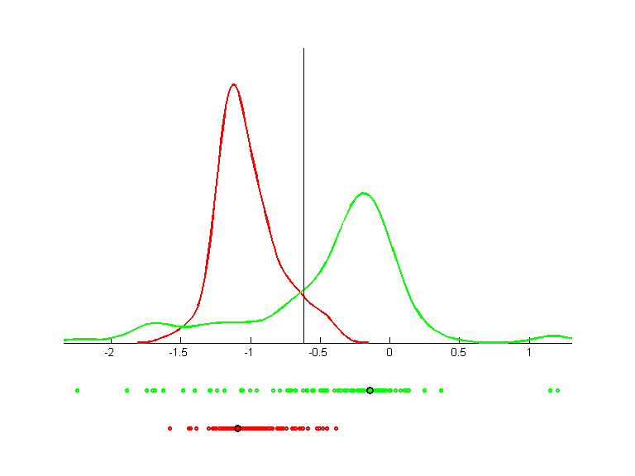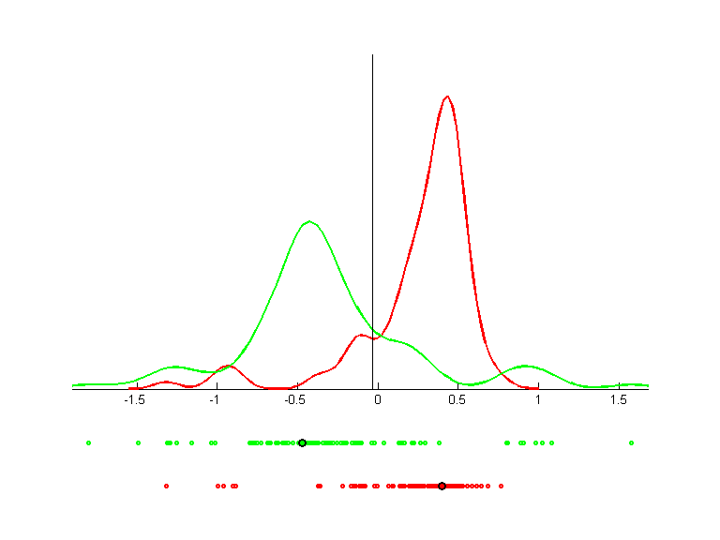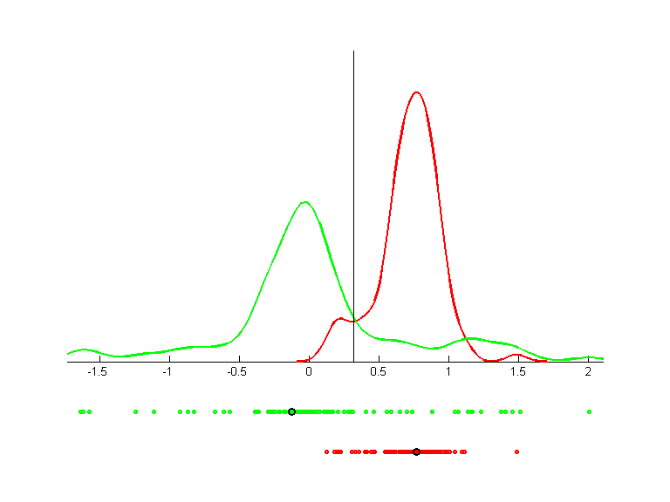 | 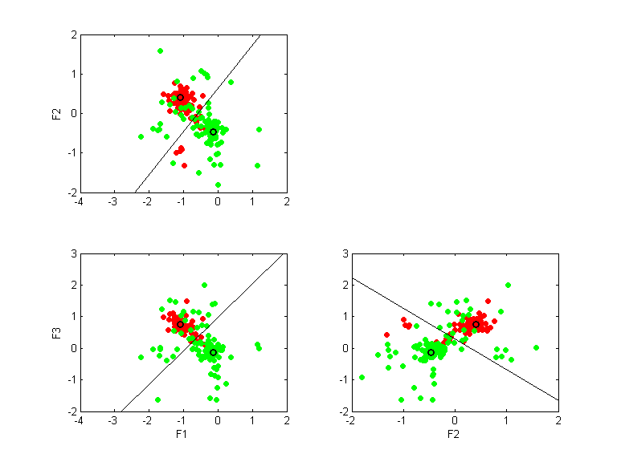

iris
Direction 1
QPC=0.8471
LVQ acc.=0.9800
LVQ 1D acc.=0.9800
--
Direction 2
QPC=0.7373
LVQ acc.=0.9667
LVQ 1D acc.=0.8933
--
Direction 3
QPC=0.4014
LVQ acc.=0.9533
LVQ 1D acc.=0.6200
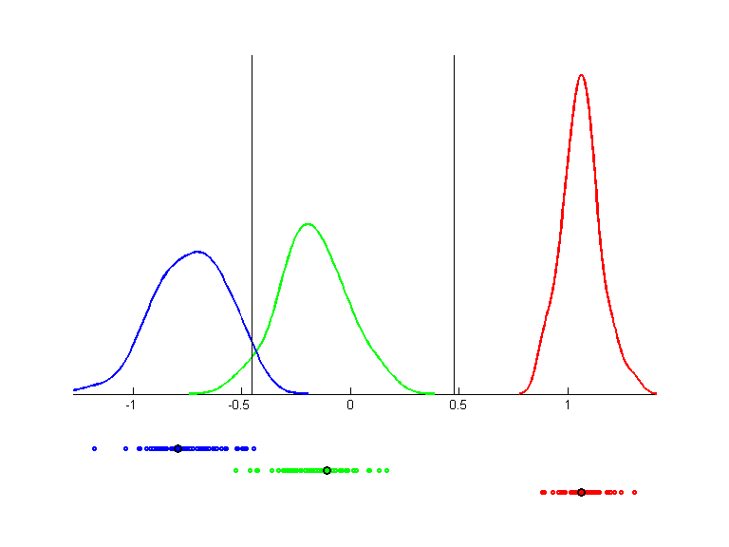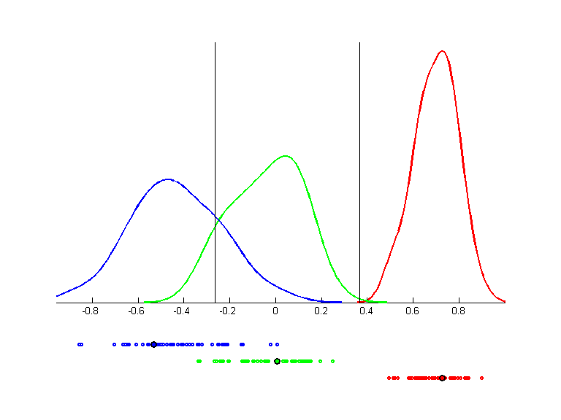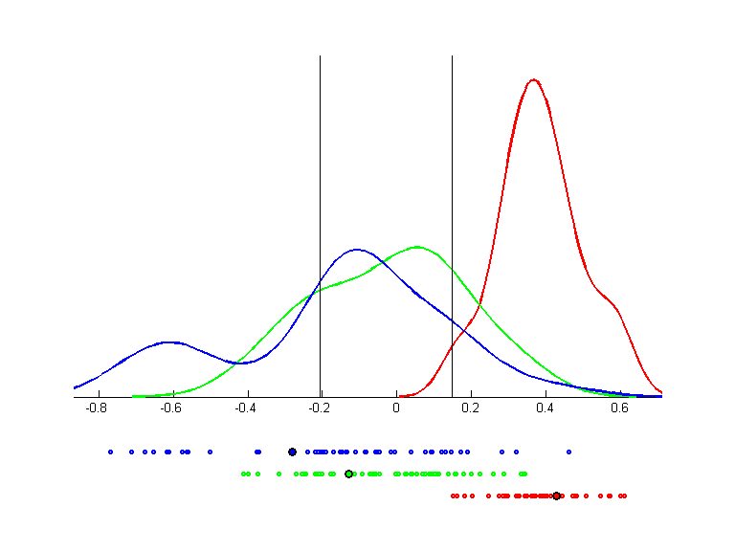 | 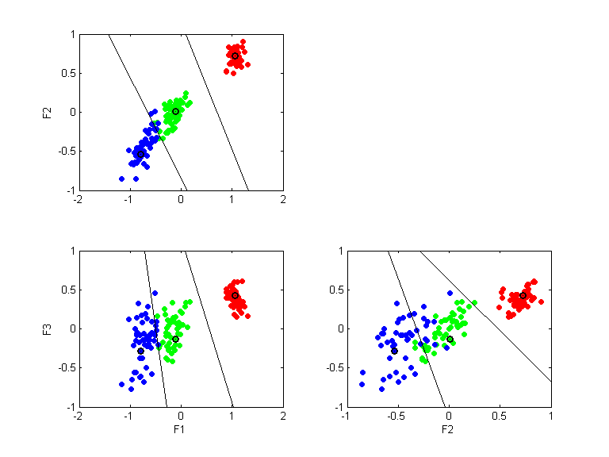

lbreast-nomis
Direction 1
QPC=0.2863
LVQ acc.=0.7112
LVQ 1D acc.=0.7112
--
Direction 2
QPC=0.1618
LVQ acc.=0.7076
LVQ 1D acc.=0.6534
--
Direction 3
QPC=0.3100
LVQ acc.=0.7148
LVQ 1D acc.=0.6823
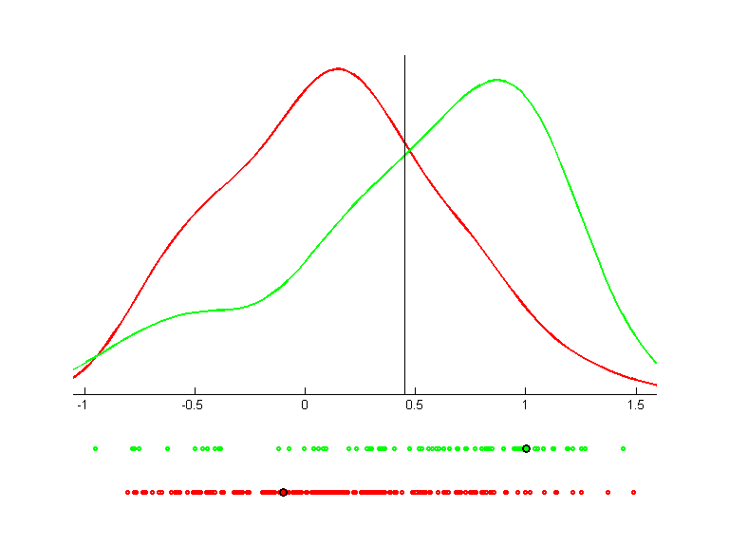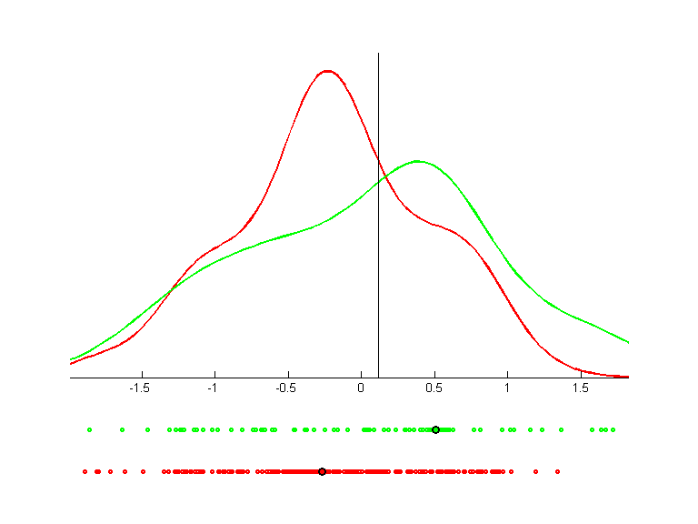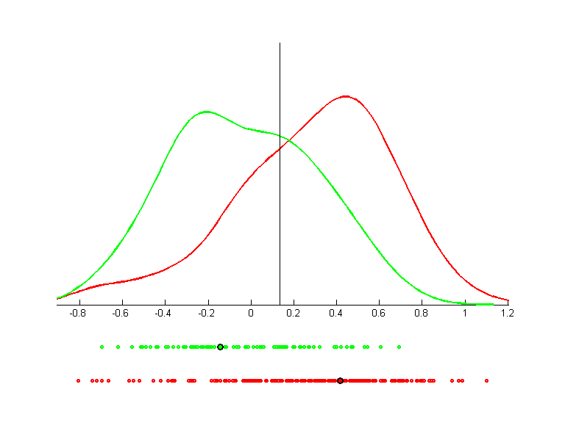 | 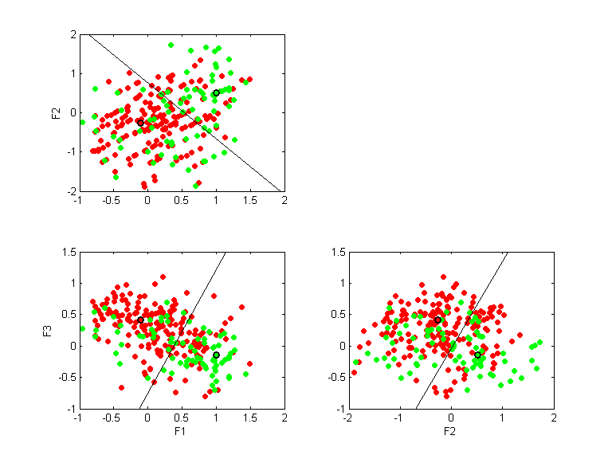

madelon_train
Direction 1
QPC=0.4173
LVQ acc.=0.7750
LVQ 1D acc.=0.7750
--
Direction 2
QPC=0.3614
LVQ acc.=0.7120
LVQ 1D acc.=0.7225
--
Direction 3
QPC=0.3299
LVQ acc.=0.6850
LVQ 1D acc.=0.7060
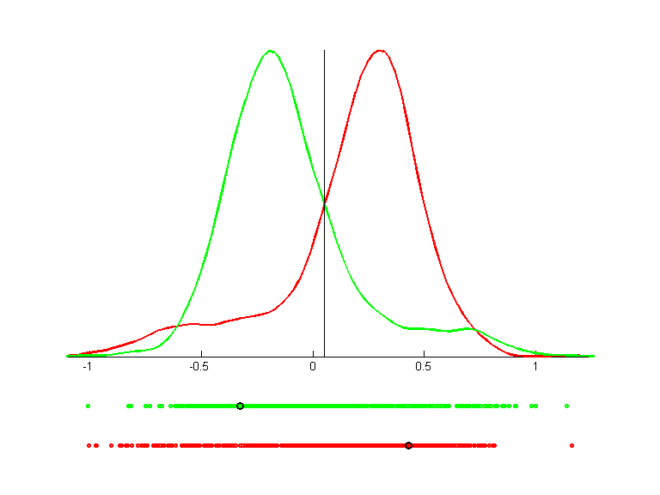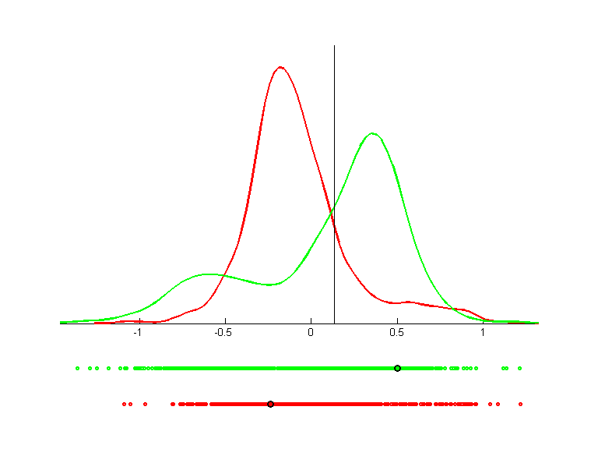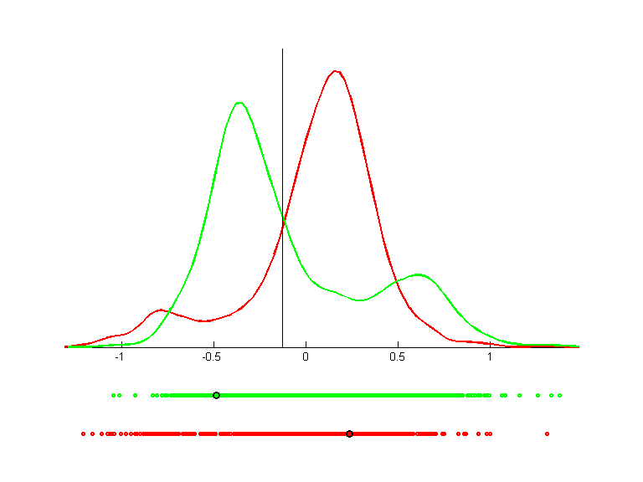 | 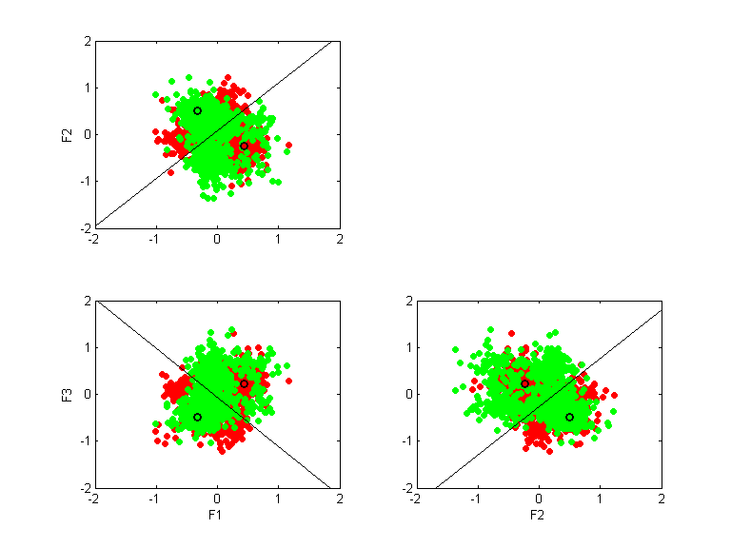

monks1
Direction 1
QPC=0.1868
LVQ acc.=0.6210
LVQ 1D acc.=0.6210
--
Direction 2
QPC=0.3894
LVQ acc.=0.6048
LVQ 1D acc.=0.7177
--
Direction 3
QPC=0.3893
LVQ acc.=0.6371
LVQ 1D acc.=0.7097
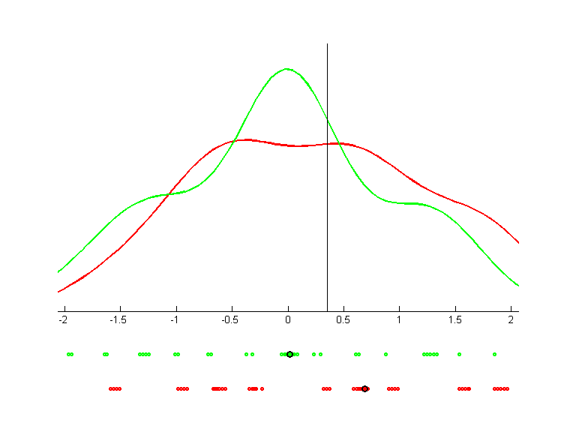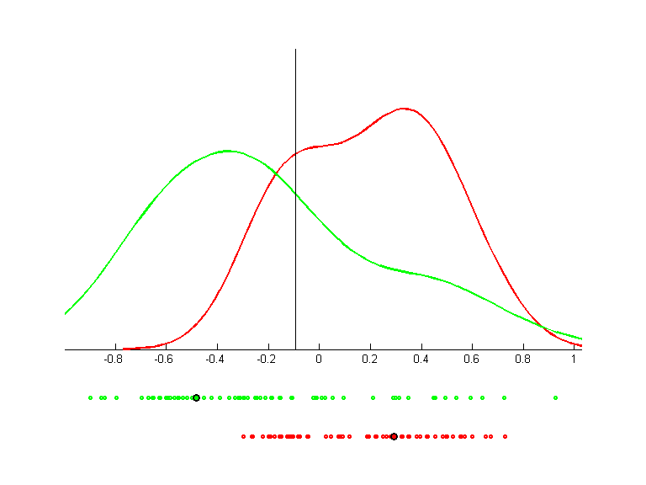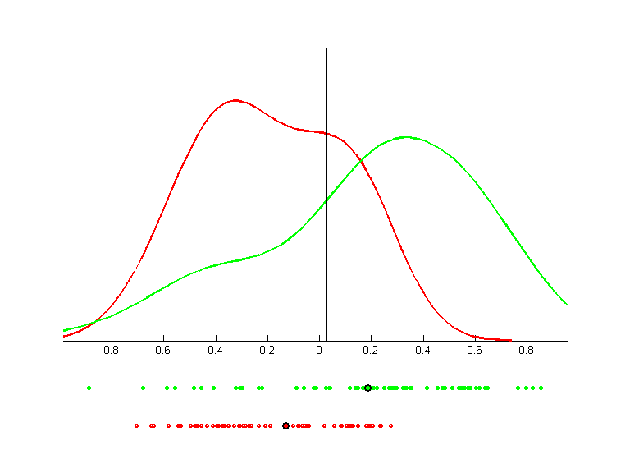 | 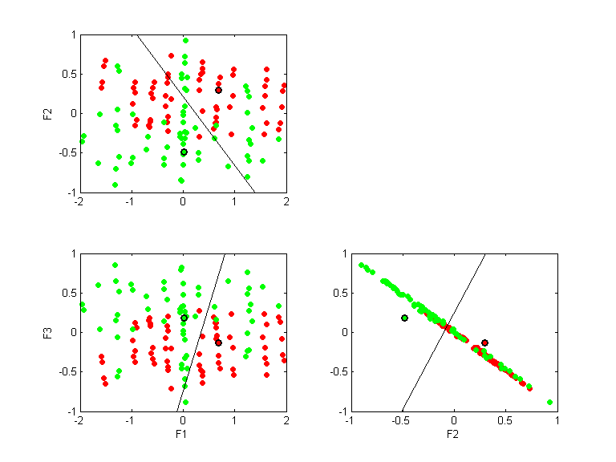

monks2
Direction 1
QPC=0.1083
LVQ acc.=0.5148
LVQ 1D acc.=0.5148
--
Direction 2
QPC=0.2050
LVQ acc.=0.5030
LVQ 1D acc.=0.5917
--
Direction 3
QPC=0.2069
LVQ acc.=0.4911
LVQ 1D acc.=0.5976
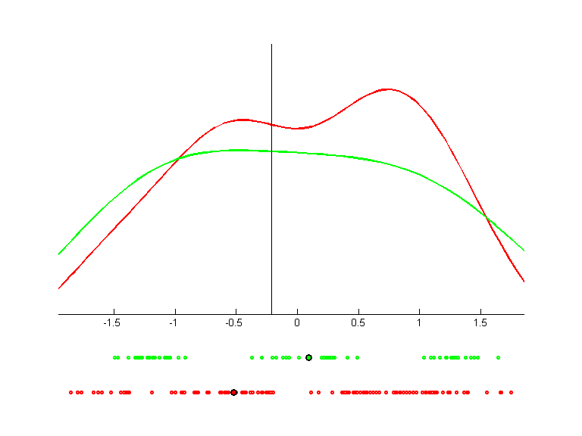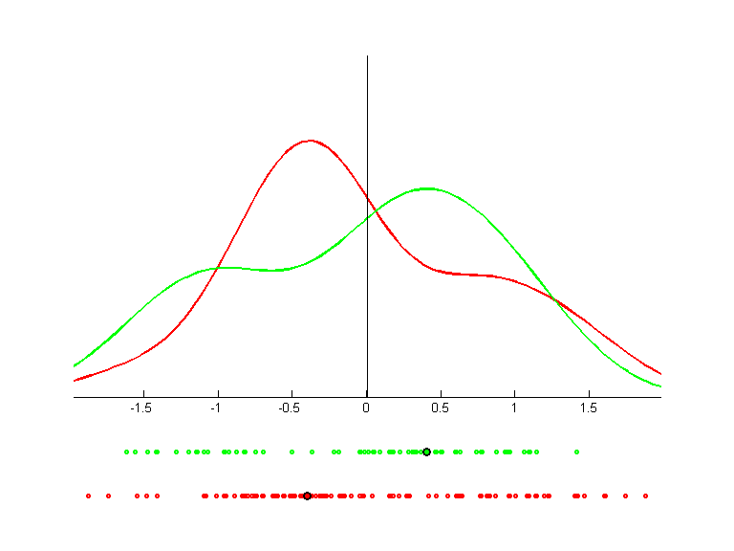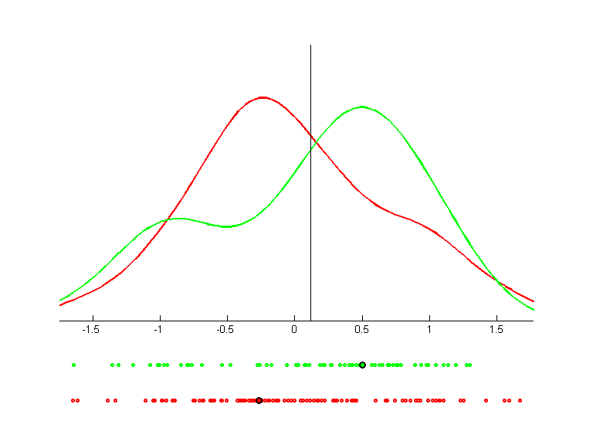 | 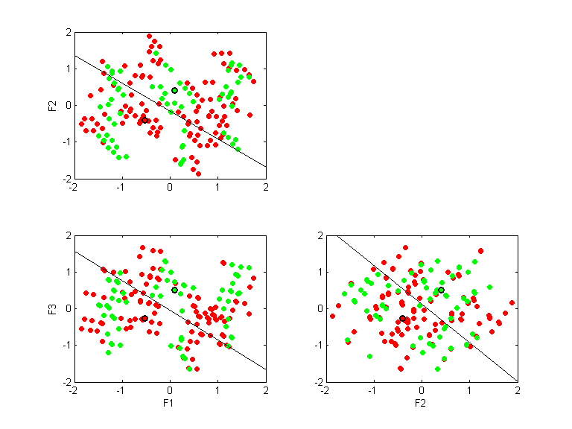

monks3
Direction 1
QPC=0.4217
LVQ acc.=0.8361
LVQ 1D acc.=0.8361
--
Direction 2
QPC=0.2650
LVQ acc.=0.7787
LVQ 1D acc.=0.5984
--
Direction 3
QPC=0.1125
LVQ acc.=0.7705
LVQ 1D acc.=0.6393
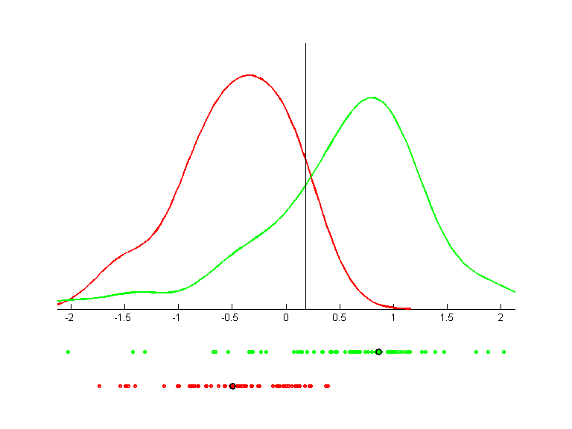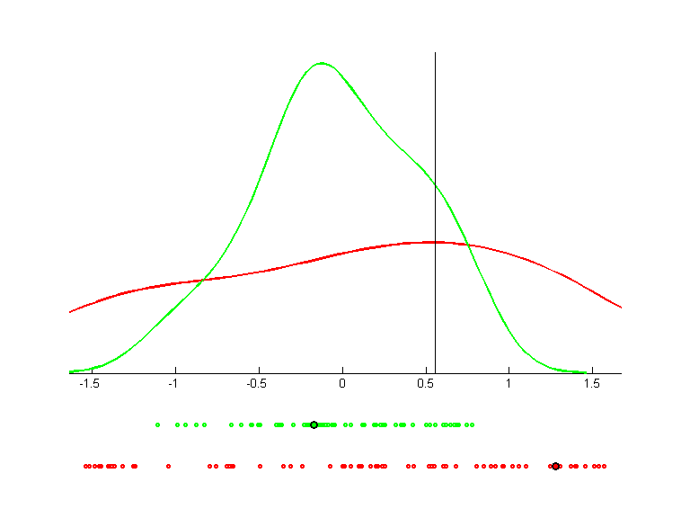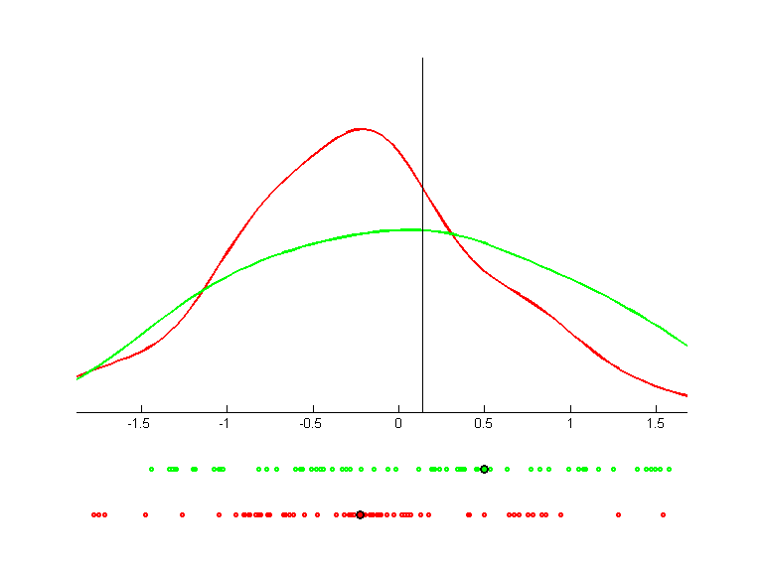 | 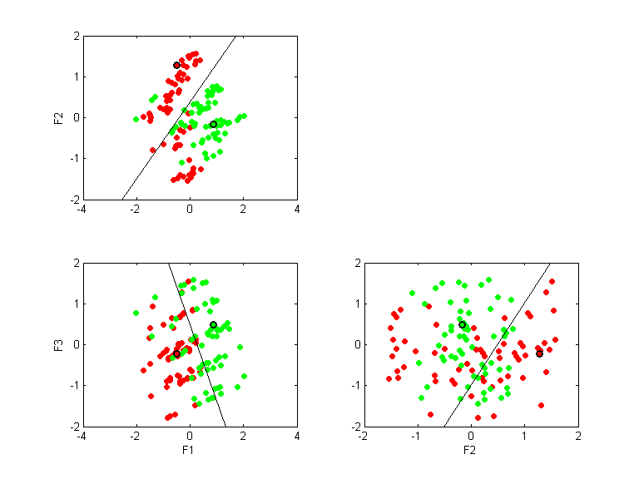

parity-10
Direction 1
QPC=0.0000
LVQ acc.=0.5029
LVQ 1D acc.=0.5029
--
Direction 2
QPC=0.0000
LVQ acc.=0.5000
LVQ 1D acc.=0.5088
--
Direction 3
QPC=0.0000
LVQ acc.=0.5049
LVQ 1D acc.=0.5039
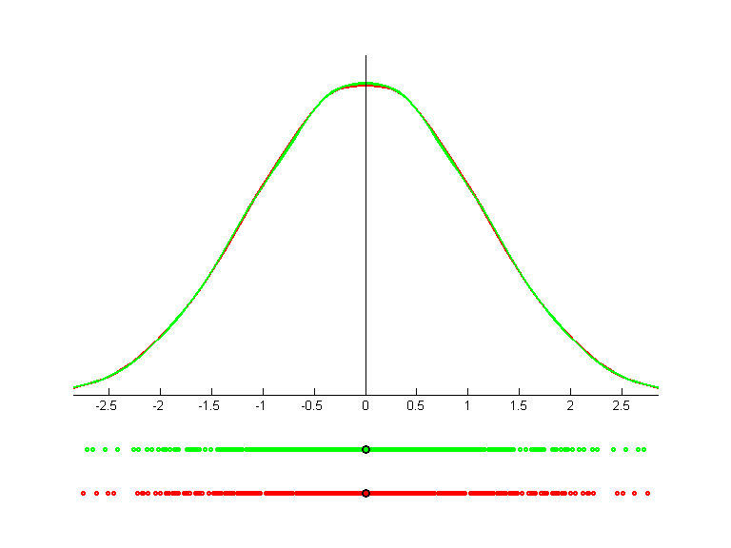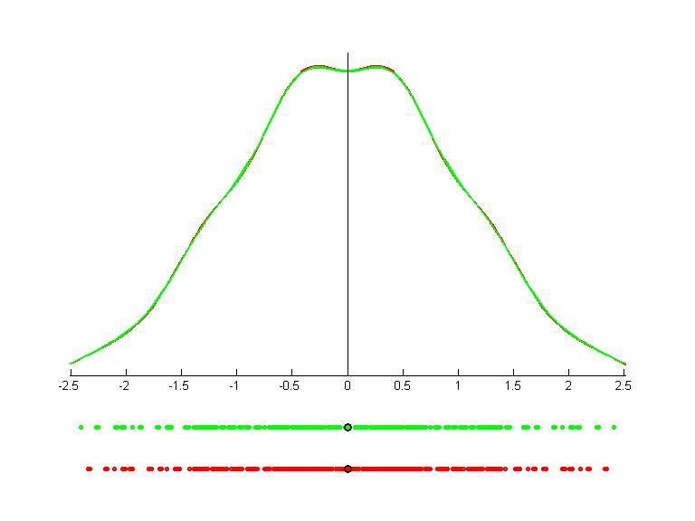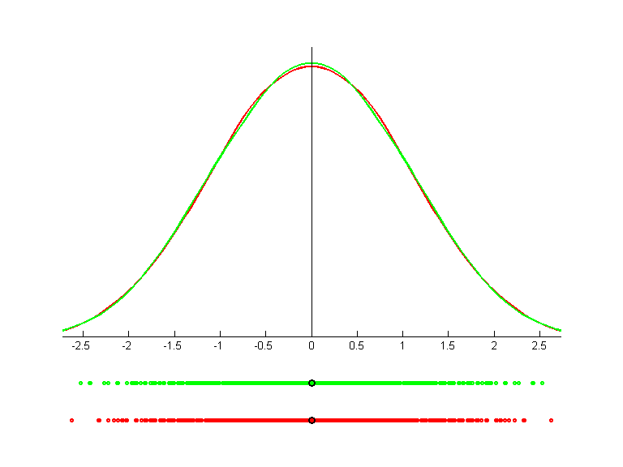 | 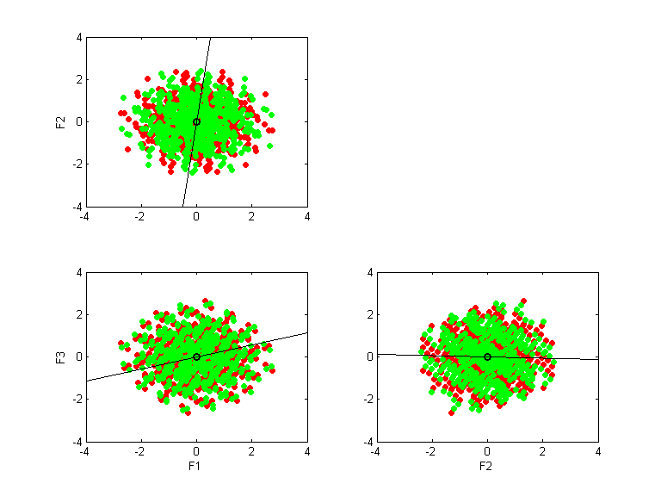

parity-9
Direction 1
QPC=0.4042
LVQ acc.=0.6367
LVQ 1D acc.=0.6367
--
Direction 2
QPC=0.3517
LVQ acc.=0.5000
LVQ 1D acc.=0.6328
--
Direction 3
QPC=0.0686
LVQ acc.=0.5313
LVQ 1D acc.=0.5664
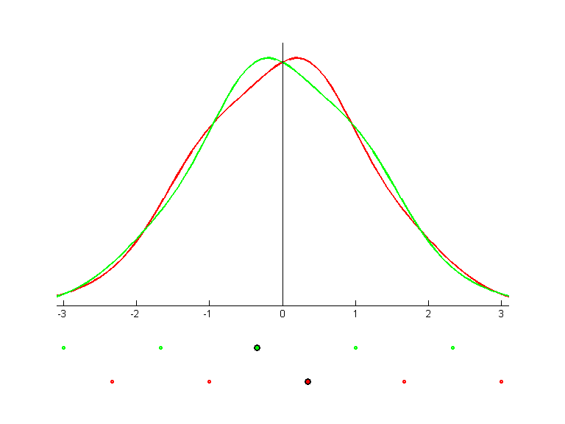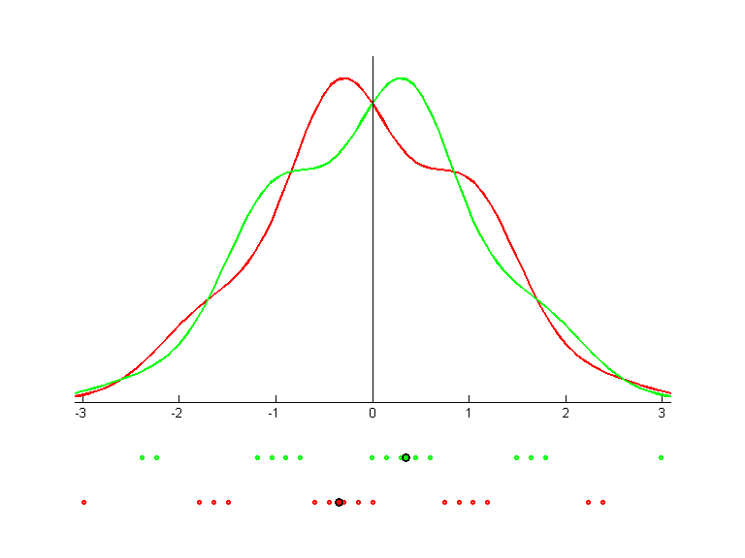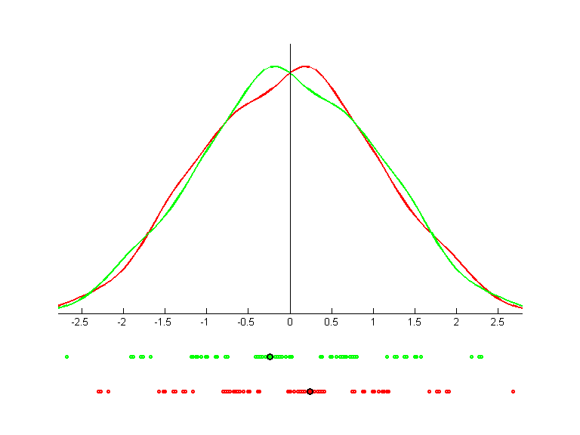 | 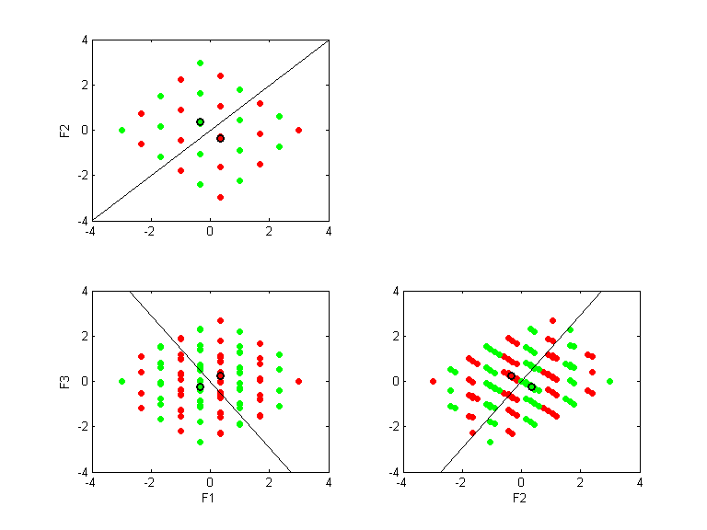

thyr-train
Direction 1
QPC=0.3439
LVQ acc.=0.5284
LVQ 1D acc.=0.5284
--
Direction 2
QPC=0.2595
LVQ acc.=0.3616
LVQ 1D acc.=0.4183
--
Direction 3
QPC=0.1753
LVQ acc.=0.3327
LVQ 1D acc.=0.3481
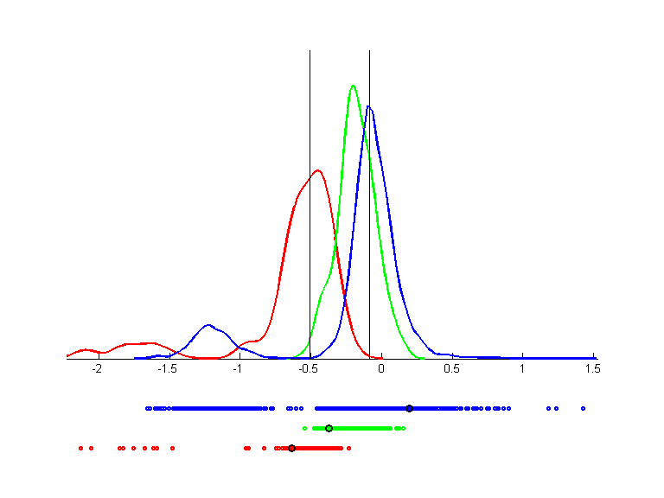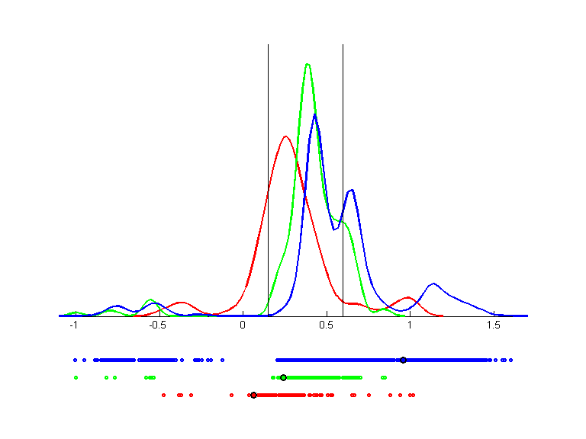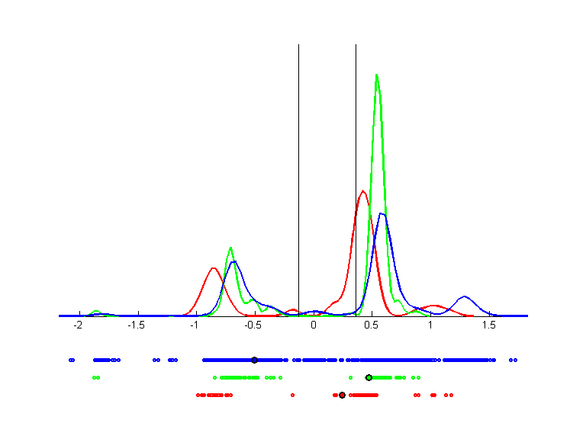 | 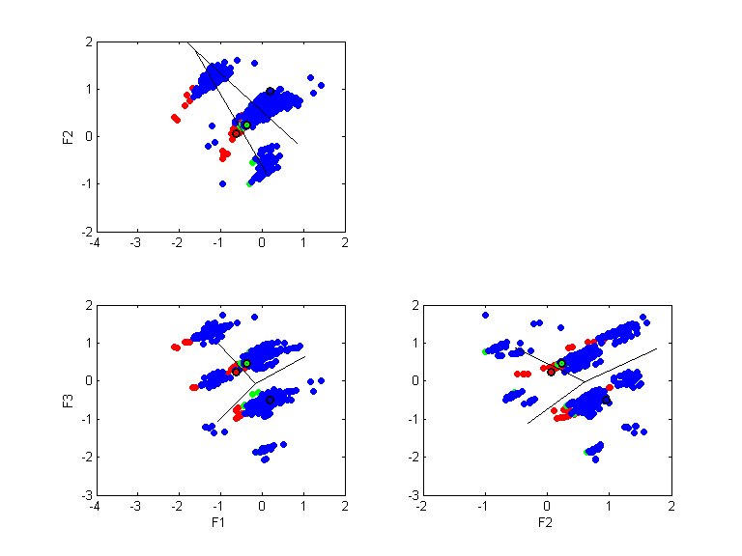

wine
Direction 1
QPC=0.6875
LVQ acc.=0.8989
LVQ 1D acc.=0.8989
--
Direction 2
QPC=0.7584
LVQ acc.=0.9775
LVQ 1D acc.=0.9551
--
Direction 3
QPC=0.4983
LVQ acc.=0.9775
LVQ 1D acc.=0.7247
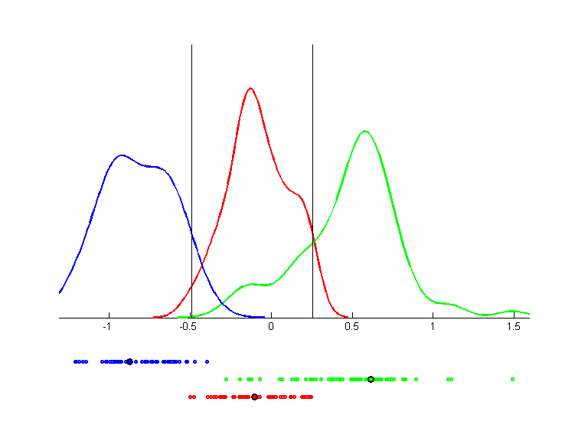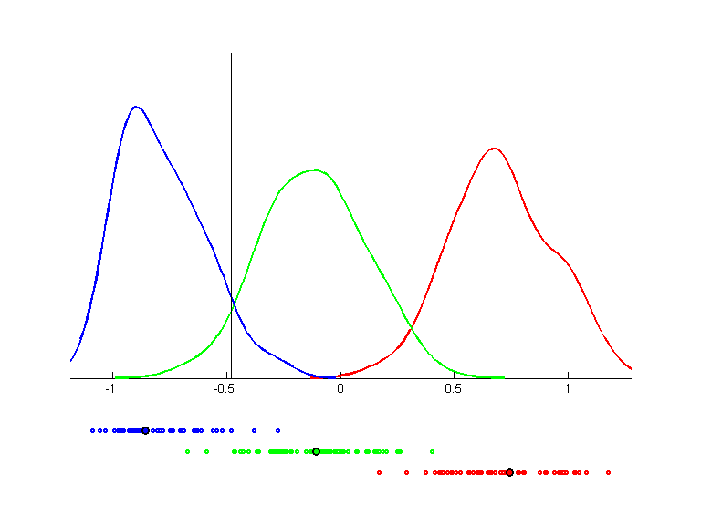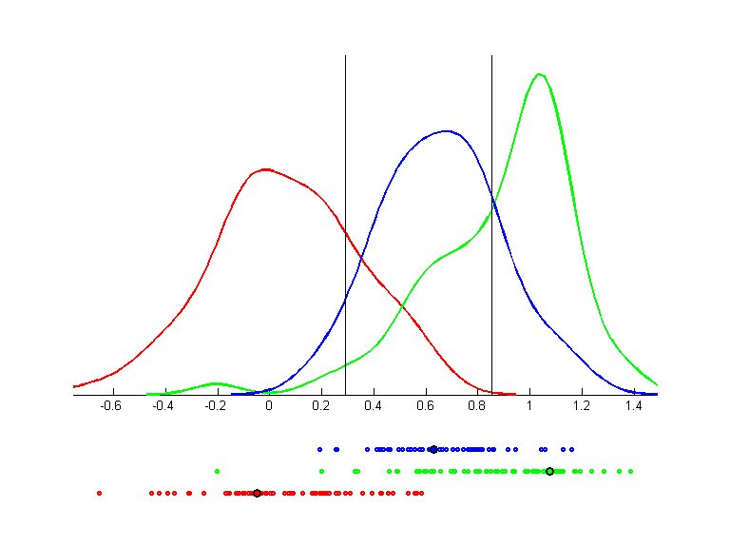 | 

