EMD on MMSE probe 2

Raven 2 class
- Dane: emd_mmse2_c2.csv
- Features: stats (avg, std, sk, kr, min, max) + stats on emd components distr (avg, std, sk, kr)
- Classes: raven scaled < 11.3 (dist: class 0 (21 vect 51.2%, 22 vect 48.8% )

Classification
- data preparation: standarization
- 10x5CV stratiffied
Model | acc | std
SVN gauss c=1, bias=0.1 | 61.6% | 14.4
kNN k=1, euclid | 57.0% | 14.4

QPC visualizations
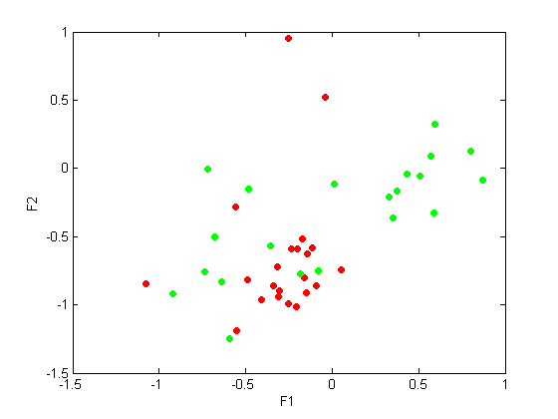
w =
Columns 1 through 7
-0.1973 0.2776 -0.0025 0.0552 -0.1026 -0.1199 -0.3357
-0.1870 0.3552 -0.1334 0.0696 -0.5460 -0.0277 -0.4003
Columns 8 through 10
-0.1334 0.4272 -0.7369
-0.1687 -0.5491 0.1647
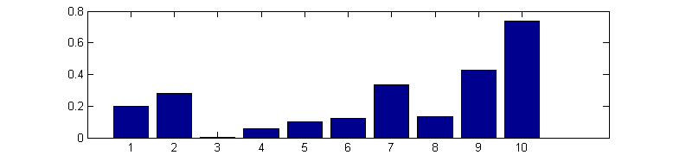
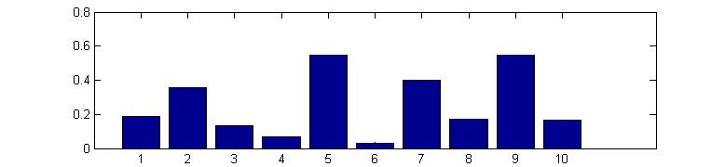
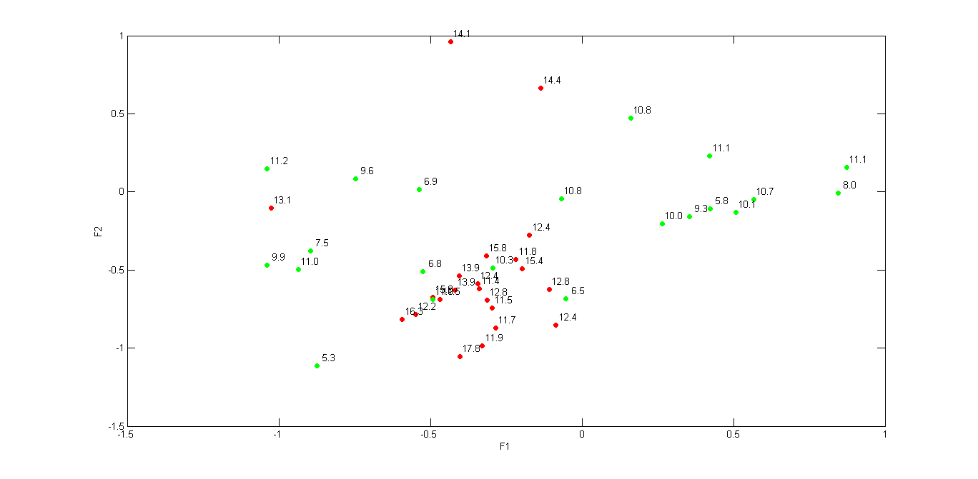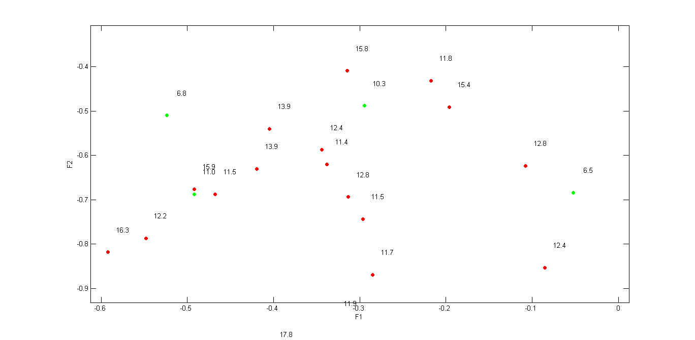

After transformation in 2D space
- GM 10x5CV kNN euclid k=3 acc 78.9 % / 11.6

QPC on 5 best features
- sele cted features 2 (std), 5 (min) , 7 (sStd), 9 (sSK), 10 (sKr)
w3 =
0.0507 -0.4182 -0.4727 0.3955 -0.6653
0.2500 -0.5526 -0.3876 -0.6441 0.2589
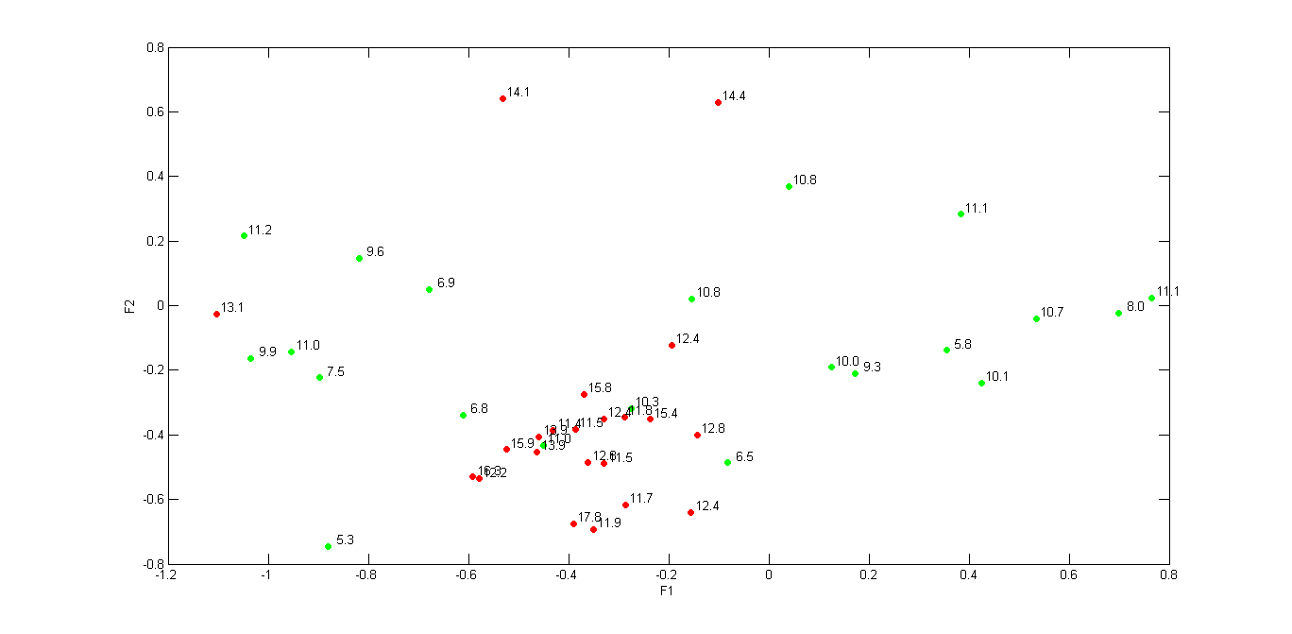
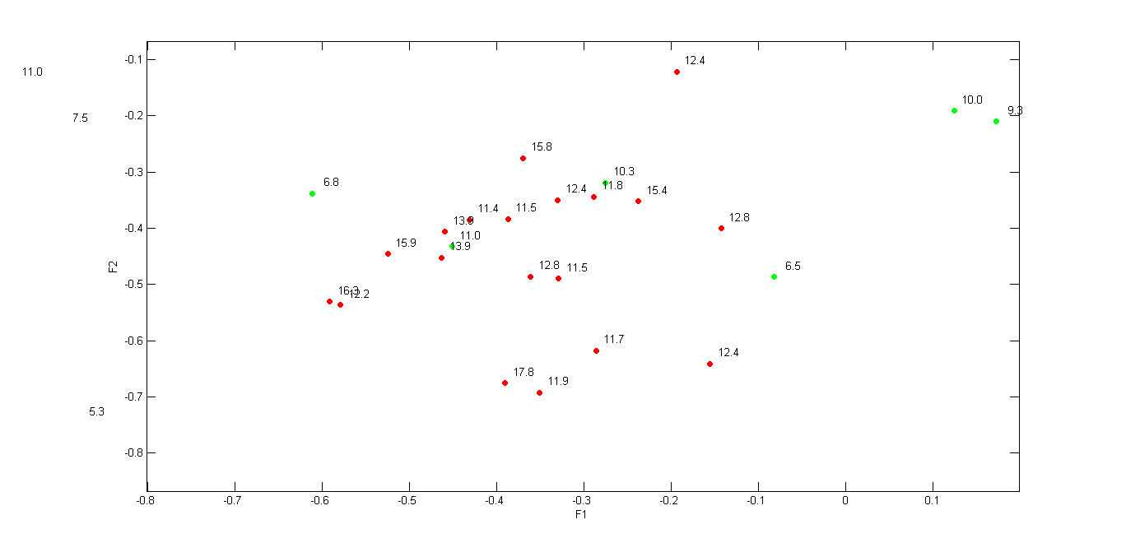

1D projection on 4 features
- features: 5 (min), 7 (sAvg), 9 (sSk), 10 (sKr)
- projection
w = [ 0.70 0.34 -1.09 3.24 ]
y = data(:,[5 7 9 10]) * w'
- rule y > 8.13 then 1 else 0 -> 72.1%
- rule y > 8.13 AND y < 8.48 then 1 else 0 -> 83.7%


